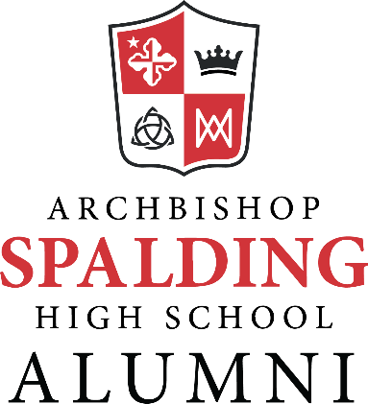
Archbishop Spalding High School Fine Arts Hall of Fame Members

Name | Class Year | Induction Year
Barbara Schwitzer |  | 2012
William Meyd |  | 2012
Brian Gunning | 81 | 2012
Zachary Nelson | 05 | 2012
James “Jimi Haha” Davies | 86 | 2014
Michael Flanagan | 96 | 2014
Donna Gunning |  | 2014
Susan Macary |  | 2014
Michelle Datz | 97 | 2016
Kim (Cline) Hovell | 02 | 2016
Luke Russell | 05 | 2016
Elizabeth (Peroutka) Schneller | 05 | 2016
James Bellinger | 08 | 2016
Regina (Pantazis) O’Hara | 02 | 2018
Sophia (Tobin) Hardesty | 03 | 2018
Jaclyn Bryant | 04 | 2018
Michael Kuhn | 06 | 2018
Stephanie Huesgen |  | 2020
Garry Phillips |  | 2020
Dan Ryan | 08 | 2020
Greg Wellham | 08 | 2020
RJ Pavel | 09 | 2020
Katie Rey Bogdan | 13 | 2020
Beth Hough |  | 2024
Courtney Brendle | 10 | 2024
David (Chaney) Correy | 04 | 2024
Ana (Tobin) Farnham | 06 | 2024
Anne (Kovarik) McNamara | 02 | 2024
Mallory Newbrough | 08 | 2024
Micaa’ A.L. Thomas | 15 | 2024

